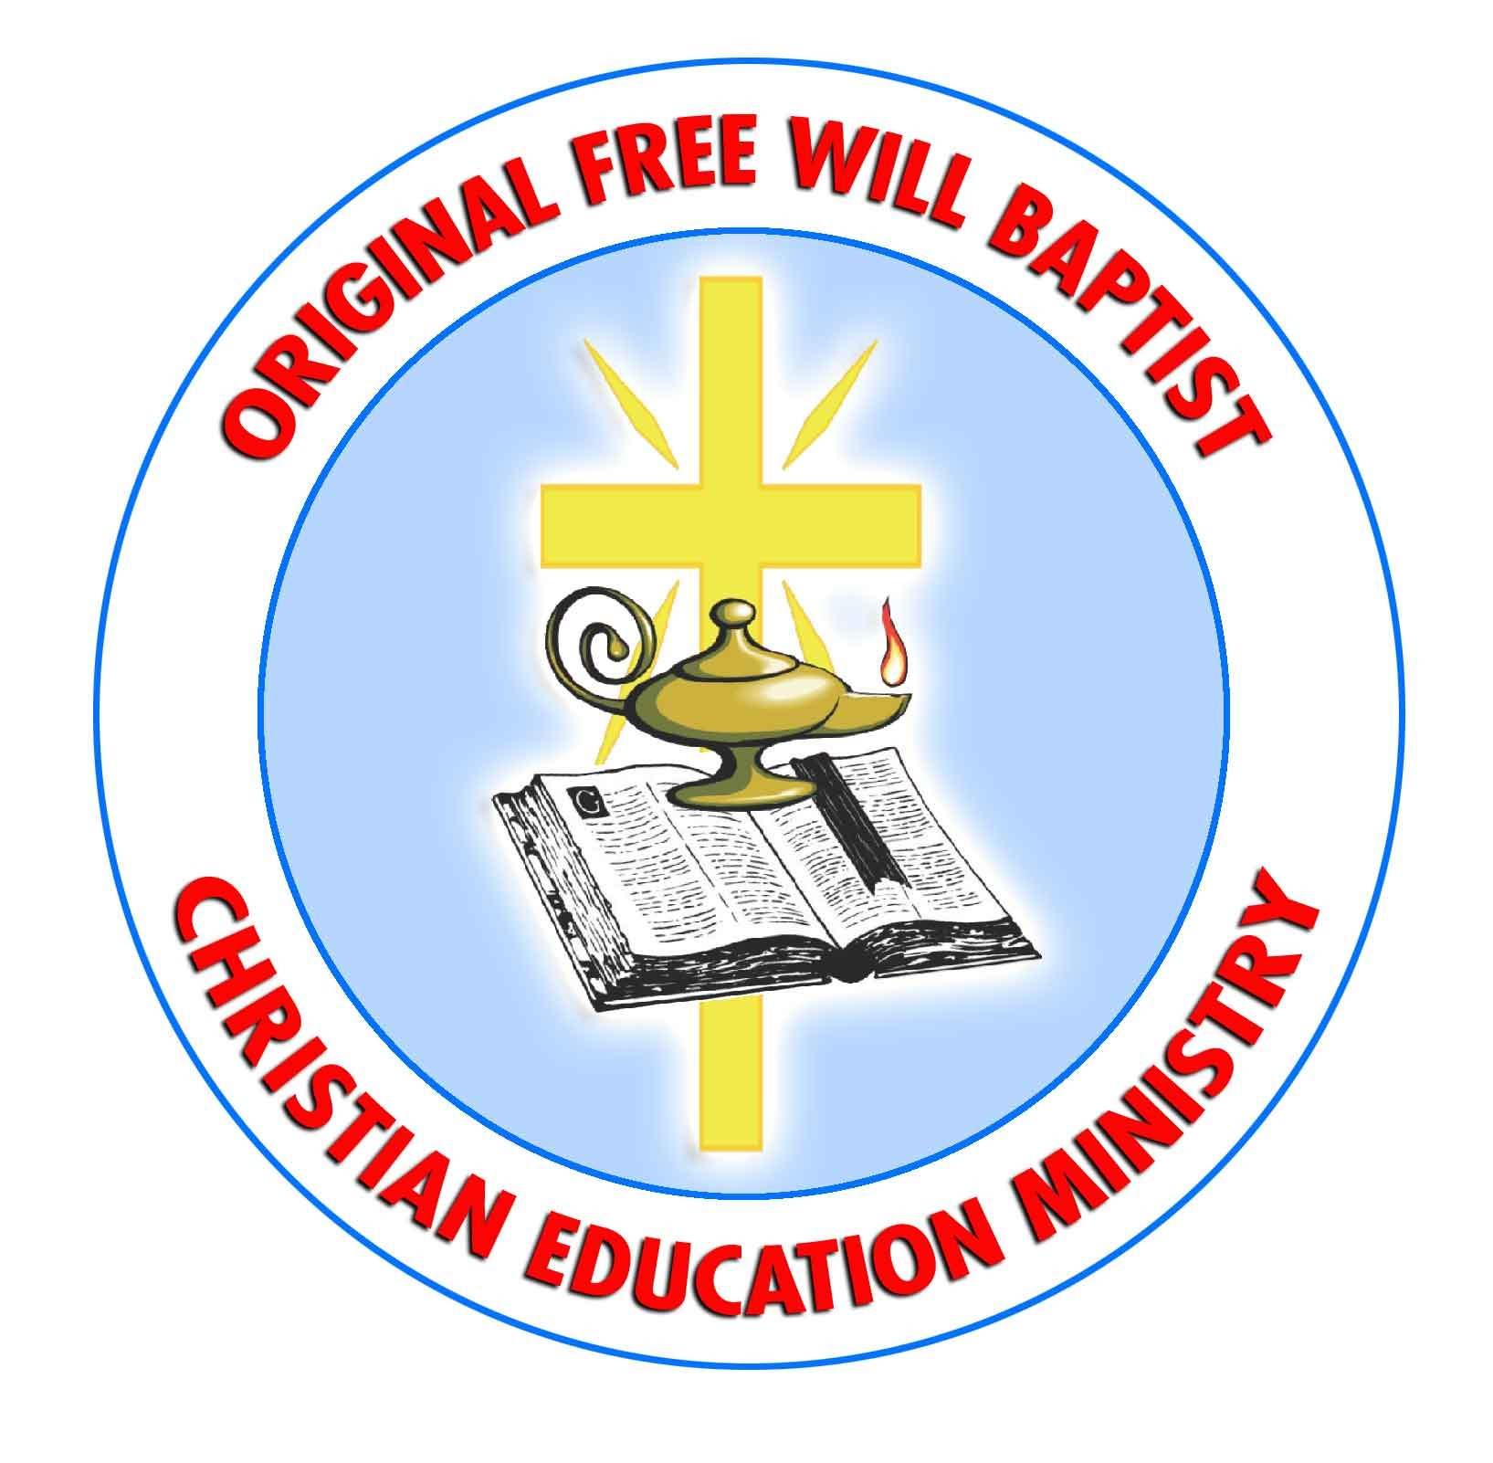

Christian Education Ministry
Report to The Woman’s Auxiliary of The Original Free Will Baptist
May 11, 2023

Great is our Lord and Worthy is He to be praised! The Christian Education Ministry and its director would like to say Thank You for standing firm in your commitment to share in this ministry and its work, you have graciously sustained us with your prayers and financial giving. The women of the OFWB contributed over $2000 to this ministry and we are so very appreciative of those gifts. In 2022 that money was used to go towards sending 16 deserving students to camp that would not have been able to go if it were not for our churches supporting our ministry. In 2023 our projected cost of providing camp scholarships is $5,400 as will be sending 19 students to either Cragmont or Camp Vandemere. So your contributions are very much needed to continue this scholarship program. We also gave two $1500 awards to recipients David and Tiffany Peck of Bethlehem OFWB as Sunday School Co-Superintendents of the year and Mr. Kevin Blackburn from Shady Grove OFWB as Sunday School Teacher of the Year. Congratulations to both well deserving recipients. We had many deserving applicants this year and the decision was a very difficult one for our panel to make. It is our desire to continue to furnish these awards as long as funding allows. Please see the display today to pick of a copy of the application and take back to your church. Feel free to make as many copies as necessary so that you may nominate a well deserving teacher or superintendent from your church. Applications are due July 21, 2023, to be received no later than July 31, 2023 in our office.
This past January 26th-39th we sponsored the Women’s Spiritual Life Retreat. This retreat which is always held on the last weekend of January at Cragmont is open to all women but with a special emphasis on our Pastor’s Wives. We urge each auxiliary to send their Pastor’s wife for this great weekend. Gift Certificates are available. The date of next year’s retreat will be January 25th – 28th, 2024.
We are here also to help with any Sunday School needs your church may have. Now is the perfect time to take advantage of the opportunity to evaluate your Sunday School Program and to look at what is working and what areas may need improvements. We continue to offer help with purchasing curriculum for our small churches who are trying to grow their SS program and cannot afford curriculum. Please reach out to us if you are struggling in this area. We also offer help with promotional ideas such as bulletin inserts, multimedia promotions, attendance awards as well as SS assessments and other ideas. Whatever challenges your Sunday School may be facing whether it is outreach or perhaps curriculum needs, please contact us and let us help.
For those that were able to attend The LIFE Conference on March 4th, thank you. We have had wonderful reviews on the speakers and workshops. We are so grateful that we were able to return to a full day of learning with three plenary speakers and 29 workshops. There will be a venue change for next year’s LIFE Conference so mark your calendars now. It will be held on March 2, 2024, at Stoney Creek OFWB Church in Goldsboro.
There are so many resources that we have and would love to share with you. We would love to have an invitation to come to your church or auxiliary meeting and share with you about your Christian Education Ministry.
Once again, Thank You. Please continue to keep us in your prayers and help us by continually offering Praise to our Heavenly Father for His good works. Respectfully submitted, Gail Heath, Director

